CS 255 System Design Document - Danny Fetter

UML Diagrams

UML Use Case Diagram

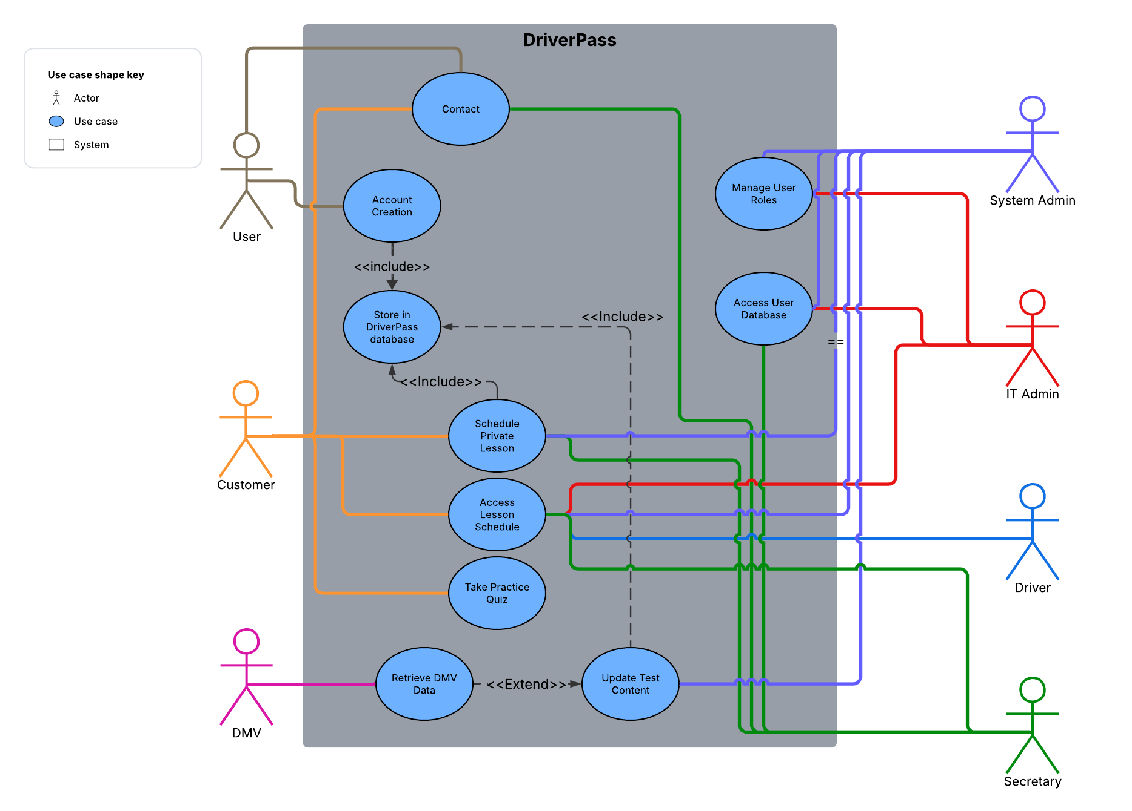

UML Activity Diagrams

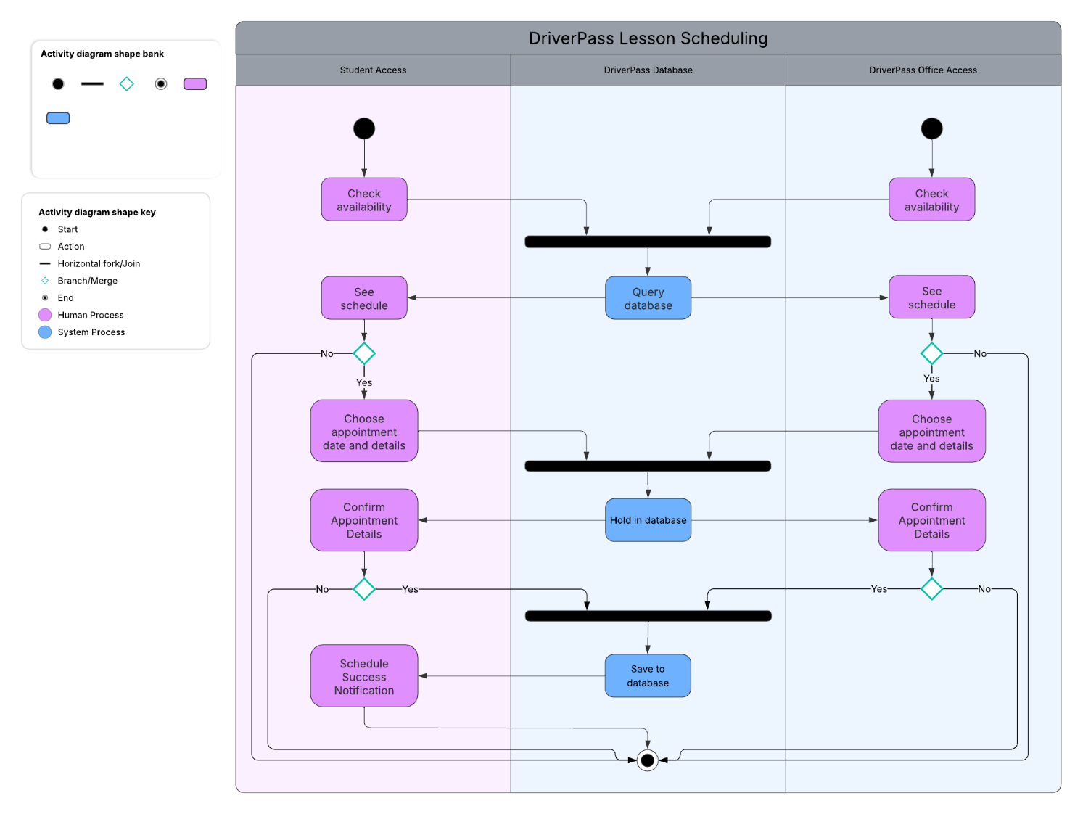

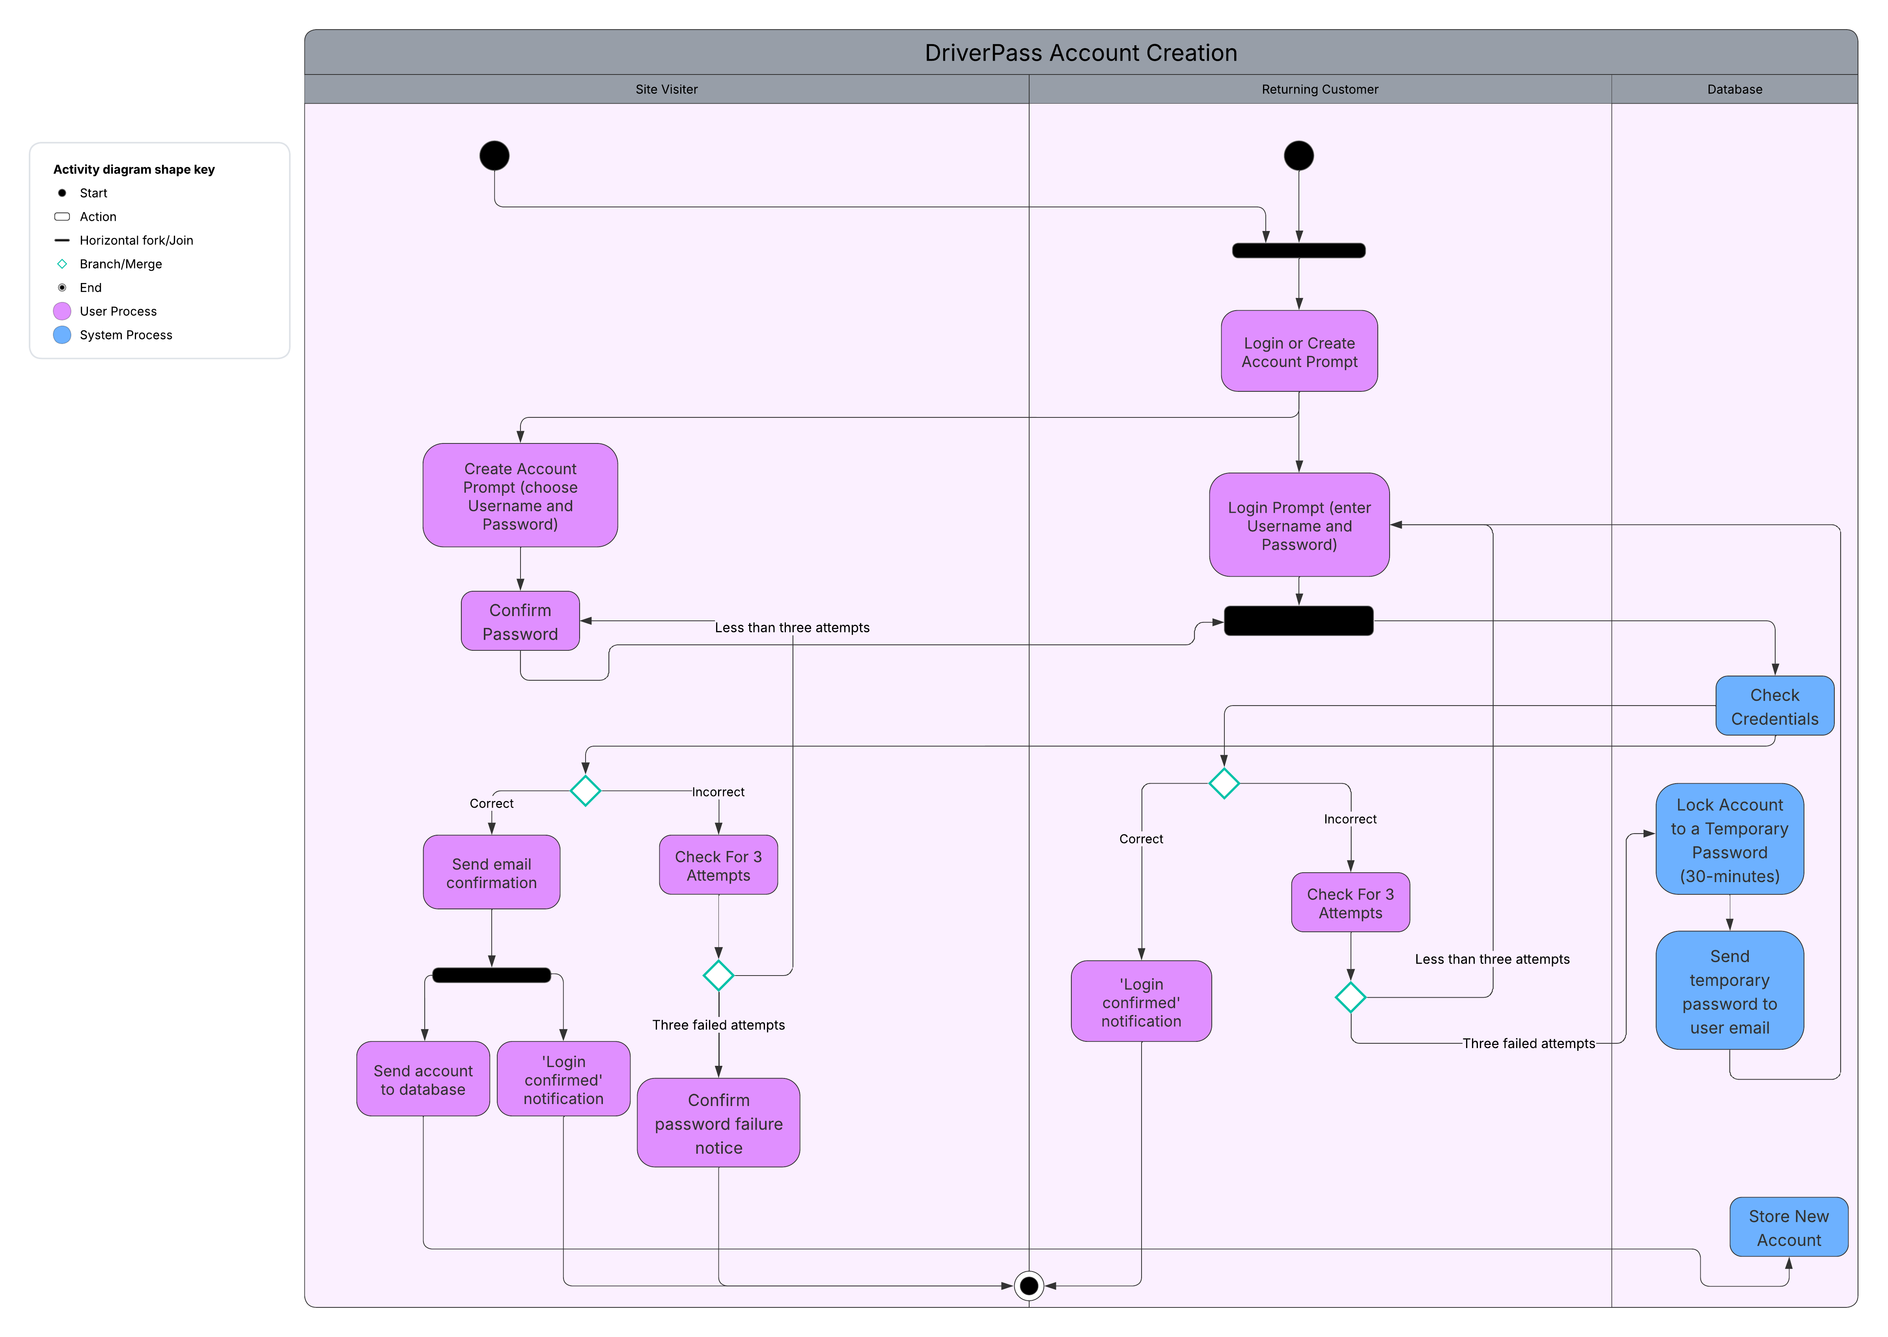

UML Sequence Diagram

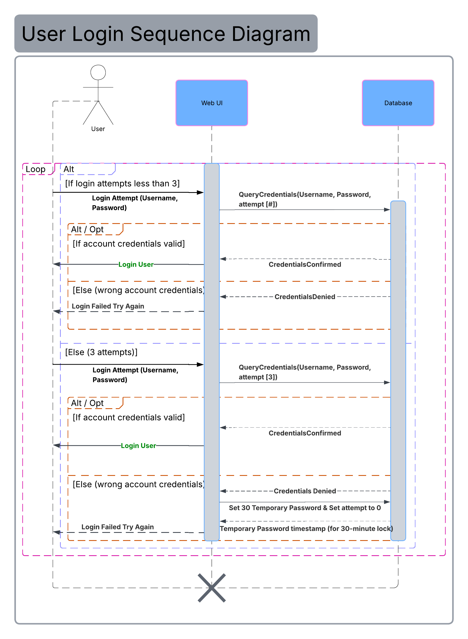

UML Class Diagram

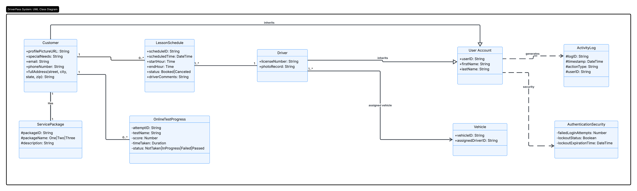

Technical Requirements

- The system shall be deployed with a web-based, cloud-hosted solution that ensures accessibility across multiple platforms: Android, iOS, Windows, MacOS, and Linux.

- Data shall be stored utilizing an encrypted database that is compatible with the chosen host.

- Data shall only be transmitted according to TLS/HTTPS protocols to ensure encryption during transit and browser support.

- Systems shall respond within 5 seconds, over both Wi-Fi and 5G connections.

- Critical updates shall be downloaded automatically, daily at 3:00 AM.

- The system shall implement a mechanism that triggers account lockouts for a 30-minute window after three failed password entry attempts.

- The system shall log all event transactions, such as scheduling a lesson or taking an online test, with userID and timestamp information to confirm each event. This data must be stored in organized database structure for ease of access later.

- The system shall allow IT admin and Driver Pass’s boss account to access Role-Based Access Controls for other accounts.

